**Estimating Biofuel Feedstock Water Footprints Using a Database and System Dynamics Approach**

*Daniel Inman, Ethan Warner[1], Dana Stright, Jordan Macknick, Corey Peck*

Abstract:

Increased biofuel production has prompted concerns about the environmental tradeoffs of biofuels compared to petroleum-based fuels. Biofuel production, in general, and feedstock production, in particular, is under increased scrutiny. Water footprinting has been proposed as a possible complete measure to evaluate water use with regards to concerns about

Water footprinting literature has often been limited in one or more of the several key aspects: complete assessment across multiple water stocks (e.g., vadose zone, surface, and ground water stocks), geographical resolution of data, consistent representation of many feedstocks, and flexibility to perform scenario analysis.

We developed a model called BioSpatial H2O using a flexible modeling and database framework. BioSpatial H2O could be used to consistently evaluate the complete water footprints of multiple biomass feedstocks at high geo-spatial resolutions. BioSpatial H2O has the flexibility to allow for simultaneous scenario analysis of multiple current and potential future crop categories under alternative conditions such those related to yield and climate.

We modeled corn grain and soybeans under current conditions as examples of current biofuel crops as a proof of modeling concept and illustrative results. BioSpatial H2O links to a unique database composed of annual spatial explicit climate, soil, and plant physiological data. A system dynamics model uses the database is used to estimate annual crop water requirements using daily time steps. Estimated green water footprints are comparable to other modeled results, suggesting BioSpatial H2O is computationally sound for future scenario analysis.

Main Paper:

**1. INTRODUCTION**

Population growth and climate change are already stressing some water-scarce regions of the world.(1) In 2005, it was estimated that about 35% of the world population experienced long-term water shortages.(2) United Nations Educational, Scientific and Cultural Organization (UNESCO) estimates that water shortages are already a constraint on economic growth in India, China, and Australia.(3) In 2013 in the United States, which serves as the geographic focus of this study, states such as Minnesota, Kansas, and Nebraska underwent moderate to extreme drought conditions.(4) Simultaneously, as climates change, Kenneth et al. (5) project that frequency of droughts will increase in parts of some U.S. regions such as the southwest, the Rocky Mountain states, and the plains states.

Water is a limited resource and agriculture is the main consumer globally.(3) Production of food, feed, and fiber consumes about 86% of the global freshwater use.(6) Water used for agriculture makes up more than 90% of water withdrawals in some developing countries.(3) Consequently, agriculture is in conflict with other users of fresh water such as municipalities and industry in many parts of the world.(7) Aquatic environments have shown signs of decline and degradation due in part to how water is managed in many nations.([8](#_ENREF_8" \o "Postel, (2000) #95))

Balancing the many uses for water will be challenging in the coming decades while trying to still meet basic human needs.(9, 10) Diverting surface and ground water without negatively impacting the environment will become challenging if water becomes more scarce.(8) Agricultural water consumption has the potential to become an even more contentious issue in the future due to expansion of biofuels. Understanding the water use implications of expanding biofuel use through water footprinting is important for managing water resources at multiple geographic scales.

*1.1. Biofuels and Water Scarcity*

Our study focuses on the largest contributor to commercial biofuel water use, biomass cultivation. Biofuel systems consume water all along the supply chain, but the major uses of water often occur in the cultivation of the biomass-feedstock and biomass-conversion-to-fuel phases of biofuel.(11) Production of crop-based transportation fuel has been reported to consume more water than fossil energy production per unit of fuel produced.([11](#_ENREF_11" \o "Fingerman, (2010) #12), [12](#_ENREF_12" \o "Wu, (2009) #15)) Existing studies have more extensive studied the relatively less spatially variable water use at the biorefinery such as Wu et al.(13) In feedstock cultivation, water is typically lost to the atmosphere through evapotranspiration during the growth cycle of cultivated feedstock.As water is diverted to production of biofuel feedstocks, the water availability for food, feed, and fiber production could decrease.(14, 15) For example, Berndes(16) reports that a large-scale expansion of biofuel energy systems would lead to increased water use, through evapotranspiration, that is potentially as large as existing water consumption from agricultural land.

fuel([17](#_ENREF_17" \o "Berndes, (2008) #8))([17](#_ENREF_17" \o "Berndes, (2008) #8)) fuel([17](#_ENREF_17" \o "Berndes, (2008) #8)).

Water use analysis is a useful tool for understanding the spatial implications of water consumption from multiple biofuel feedstocks, including cellulosic crops. Water use analysis is important for determining the impacts that the expansion of biofuel use could have on water resources.

Increasing water use efficiency of existing water resources may reduce the risk of conflicting with other uses.([18](#_ENREF_18" \o "Chum, (2011) #67))Recent studies indicate that considerable improvements can be made in efficiency of water consumption in the production of agriculture and, specifically, biofuel crops.(12, 17, 19-21) For instance, perennial energy crops could reduce overall water use if grown on extensively managed land, such as arable fields used intermittently as pasture for grazing animals.(18) Biofuel systems can use a range of agricultural, industry, and forestry related wastes and residues that have little to no direct claims on water consumption and are higher yielding feedstocks.(21) Removal of wastes and residues may have implications for the hydrological cycle, but their impacts depend on the prior use of the waste or residue (e.g., left in field or sent to land fill). Scenario analysis of these and other ways to improve water use efficiency is biofuel systems is needed.

*1.2. Water Footprinting Definition*

We use definitions and concepts from the U.S. Geological Survey (co.water.usgs.gov/infodata/wateruseconcepts.html) and seek to evaluate biofuel feedstock water footprints. The water footprinting method we use characterizes total water consumption along with the sources of the water consumed.(22) Therefore, we consider both “green” and “blue” water consumption in this paper. Our definition of green water and blue water are in agreement with other literature such as Yeh et al.(23) and Hoff et al.(24). Rockström et al.(25) describing these concepts:

“… green water is the soil water held in the vadose zone, formed by precipitation and available to plants, while blue water refers to liquid water in rivers, lakes, wetlands and aquifers, which can be withdrawn for irrigation and other human uses. Consistent with this definition, irrigated agriculture receives blue water (from irrigation) as well as green water (from precipitation), while rain-fed agriculture only receives green water (pg. 178).”

Blue water withdrawn from aquifers (outstream) and surface water (instream) can be consumed or released as a part of its utilization. Instream use removes water through incorporation into the crop, evaporation, and evapotranspiration. Outstream use is water released into the environment without quality changes and therefore can be used elsewhere for agriculture, industry, and drinking water.

**2. REVIEW OF CURRENT WATER FOOTPRINTING MODELS AND ASSESSMENT METHODS**

We reviewed existing water footprinting models and assessment methods in order to understand the strengths and limitations of existing analysis. consumption([26](#_ENREF_26" \o "USDA, (1995) #4))([27](#_ENREF_27" \o "Parton, (1998) #5))footprints These models and studies were excluded from the scope of this paper.

*2.1. Penman-Monteith Method*

The Food and Agriculture Organization’s (FAO) Penman–Monteith method(28) is an established crop evapotranspiration model using plant physiology, soil data, and climate data to calculate irrigation requirements.(28) Many studies (e.g., Gerbens-Leenes et al.(29) and Hoekstra et al.(30)) use forms of this method to calculate crop water footprints. The Penman–Monteith method estimates evapotranspiration as shown in the equation below.

Eq. 1

ETc is total evapotranspiration (mm day−1) from a crop or “c”. Kc, a crop coefficient, accounts for plant characteristics, such as albedo and crop height, that distinguish a crop from the reference surface. Kc represents a crop based constant that varies throughout the growing season, refer to FAO paper 56(28) for common ranges observed across a number of crops . ETo represents the reference crop evapotranspiration (mm day−1). The ETo characterizes climate effects and is based on a calculation using temperature, solar radiation, wind speed, and relative humidity as shown in the equation below.

* Δ = slope of the vapor pressure curve (kPa ◦C-1)
* T = average air temperature (◦C)
* γ = psychrometric constant (kPa ◦C-1)
* es = saturation vapor pressure (kPa)
* ea = actual vapor pressure (kPa)
* Rn = net radiation at the crop surface (MJ-day m-2 )
* G = soil heat flux (MJ-day m-2)
* u2 = wind speed at 2 m (m s-1).

*2.2. Public Modeling Systems*

There are several publically available modeling systems based on the Penman-Monteith method.(28) FAO’s CROPWAT model(31) formulizes the Penman-Monteith method into a model in which users can input data to the equation to calculate crop water requirements and irrigation requirements based on soil, climate, and crop physiological data. CROPWAT is a platform for calculations and does not contain its own datasets. FAO offers sources of climatic data, such as CLIMWAT,(32) which includes more than 5,000 stations globally.

A model closely related to CROPWAT, the Water Footprint Assessment model (<http://www.waterfootprint.org/tool/home/>, Water Footprinting Network) uses CROPWAT structure and global climatic, soil, and plant physiological data to evaluate aggregate water consumption. The Water Footprint Assessment model provides water footprints (including blue and green water consumption) of multiple agricultural crops and industrial and drinking water sectors on a global, country, or water basin level. Higher resolution estimates of water consumption are not currently available.

Similar to the Water Footprint Assessment model is the Consumptive Use Program+ (CUP+)(33). CUP+ estimates crop water requirements and irrigation requirements based on soil, climate, and crop physiological data with geographic coverage limited to the state of California. The application has the capacity to study the impact of climate change on water requirements and irrigation water needs. Unlike CROPWAT, CUP+ contains initial climate, soil, and plant physiological data for assessment, and unlike the Water Footprinting Assessment model, CUP+’s assumptions (e.g., wind speed and average temperature) can be modified by the user.

Ever the last few years Argonne National Laboratory (ANL) has developed a county level life cycle water footprinting model.(34) The model has been used to evaluate several commercial and residue based biofuel feedstocks (e.g., corn and corn stover), the results of which are available online (<http://water.es.anl.gov/>, ANL). ANL’s modeling framework has recently been used to evaluate other advanced feedstocks such as forest residues and algae.(35, 36) The model also evaluates the volume of freshwater that is required to assimilate the load of nutrients/chemicals on the basis of water quality standards (i.e., grey water).

*2.3. Modeling and Assessment Strengths and Weaknesses*

Water impacts of biofuel systems are potentially highly variable and often determined within the local contexts related to factors such as water availability, the interactions of land and water, and climate for a particular time frame.(37)

Recent publications on biofuel water consumption have raised awareness of the potential for increasing agricultural water consumption for biofuel production to impact other uses of water (e.g., other agricultural uses, industry, and municipal) and the environment.(16, 21, 30, 38, 39) The existing literature exhibits differences in scope, system boundaries, definitions, and methods, which hampers drawing sufficient understanding of the water impact of biofuel water consumption.(37) With regards to the U.S., existing literature generally provide data to make broad comparisons across current commercial biofuel feedstocks at the state and sometime the county level.(34, 38, 40-42)

Many initial water footprinting studies only account for water that is applied through irrigation (i.e., blue water).(12, 43, 44) Irrigation is a major use of water, but about 80% of global agriculture production and 85% of the major U.S. biofuel feedstock, corn grain, is exclusively rain-fed (i.e., green water).(12, 45) Analyses that only account for blue water overlooked a large portion of the overall water consumption from rain water. Also, green water consumption, if not allocated to crop production or other uses, can influence the availability of blue water.(11) For example, increases in the green water footprint can increase the time needed for aquifers to recharge their water storages.

Most studies that model blue and green water footprints lack high spatial resolution. Only recent studies have begun evaluating average county level water footprints in the U.S. been published.([35](#_ENREF_35" \o "Chiu, (2013) #117), [36](#_ENREF_36" \o "Yi-Wen, (2013) #116), [40](#_ENREF_40" \o "Chiu, (2012) #64)) In most other studies results are aggregated to a global, national, or state-level average. Aggregate results can be misleading and give the impression that water consumption is consistent over the evaluated geographic area. Variability in water consumption can be high and impacted by a myriad of interacting factors such as local climate, soil characteristics, crop management practices, and plant philological parameters, to name a few; see Allen et al.([28](#_ENREF_28" \o "Allen, (1998) #31)) for a detailed description of the factors that influence crop water consumption.

Biofuel feedstock water footprinting can also be highly variable because of the numerous possible feedstocks that can currently and potentially be used in the future in biofuel production. Figure 1 presents a generalized outline of many biomass production systems including biofuels. Currently, biofuels are typically produced from oil, sugar, and starch crops. Currently, lignocellulosic crops are mostly used for heat and power, but may be used in large quantities for biofuels in the future. The choice of feedstock has a significant impact on the overall water consumption related to a given biofuel pathway. Each of the feedstock choices illustrated in Figure 1 has a different water requirement, both in terms of a crop’s physiological water needs and in terms of where a crop is typically grown. Across the reviewed literature a relatively comprehensive assessment of biofuel feedstock options using a consistent set of methods is lacking, but recent efforts by ANL are moving to well towards this goal for commercial or near commercial biofuel systems.([34-36](#_ENREF_34" \o "Wu, (2012) #118))

Many existing water footprinting efforts are focused developing and refining a precise snapshot approach to historic and near future water footprinting. Decision-making based on these snapshots of water consumption of biofuels is difficult. Decision-making is often focused on planning or examining the potential impacts of decisions or potential decisions on the future rather than on only existing commercial or near commercial biofuel systems. No spatially explicit modeling efforts consider alternative non-historic conditions (e.g., climate change) that might impact future biofuel water consumption was found. Making choices between feedstocks that could achieve similar ends (e.g., policy requirements) but have different implications for water consumption necessitates the ability to evaluate and compare them. Exploring alternative future conditions is particularly important for understanding the potential future effects of selecting among multiple crop options and water consumption management practices for biofuel feedstocks. Systematic assessment of those multiple biofuel feedstock crops under alternative conditions such as climate is currently lacking.



**Figure 1.** Pathways of agricultural feedstock to energy, food, feed and fiber uses.

**3. DATABASE FRAMEWORK AND SYSTEM DYNAMICS APPROACH**

Our water footprinting tool, BioSpatial H2O, is a novel modeling approach for evaluating water footprints. We developed a BioSpatial H2O to have the flexibility to allow for simultaneous scenario analysis of multiple current and potential future crop categories under alternative conditions such those related to yield and climate. The model could be used to consistently evaluate the complete water footprints of multiple current and potential future biofuels feedstocks at high geo-spatial resolutions. The model is designed to estimate green water consumption based on climatic and soil data and as well as blue water consumption based on user determined assumptions and remaining physiological requirements of a crop. BioSpatial H2O allows for water footprinting at specific climate stations (i.e., our lowest resolution datasets). BioSpatial H2O can evaluate a diversity of U.S. agricultural feedstocks including most of those shown in Figure 1 including several we could not find water footprinting literature on. Finally, BioSpatial H2O is a flexible platform for scenario analysis and adoption to other conditions such as climates and geographic locations. BioSpatial H2O is mostly limited by the datasets and data resolution that is available for a geographic area.

*3.1. Model Overview*

Complex systems, such as those related to the environment, often exhibit unexpectedly rapid or sluggish changes in response to conditions such as changing climate, technology, socio-economics, and public policy. (46) Forethought to anticipate unintended consequences and understanding the dynamics of a system that prevent change is necessary for effective decision making about risk management. For example, decision-making about cellulosic biofuel feedstock research may seek to minimize the risk of water competition with current agricultural uses of water. An understanding of alternative cellulosic feedstock water requirements under different climatic conditions in alternative regions could aid the decision-making process.

BioSpatial H2O uses a SD modeling framework that is underpinned by a high spatiotemporal climate and soils dataset;(47, 48) the model has been developed in STELLA.(49) SD is an approach for framing, discussing, and understanding the behavior of complex systems over time. It uses internal feedback loops, stocks and flows, and time delays to model this behavior. SD models can be powerful tools for generating and communicating important insights about complex systems to the public,(50) and SD has long been used to examine and inform a wide variety of public policy questions and applications.(51)

Figure 2 illustrates BioSpatial H2O’s generalized data process. BioSpatial H2O consists of four main components: the database framework for managing data, the STELLA model, a Visual Basic for applications automation script, and visualization of results. Our model uses climate and soil data inputs from Cligen and SSURGO2.1/STATSGO2 to calculate the water footprinting, using a daily time step for 2,648 stations across the United States.(52) The model can be found via the Bioenergy Knowledge Discovery Framework or Github.[2]

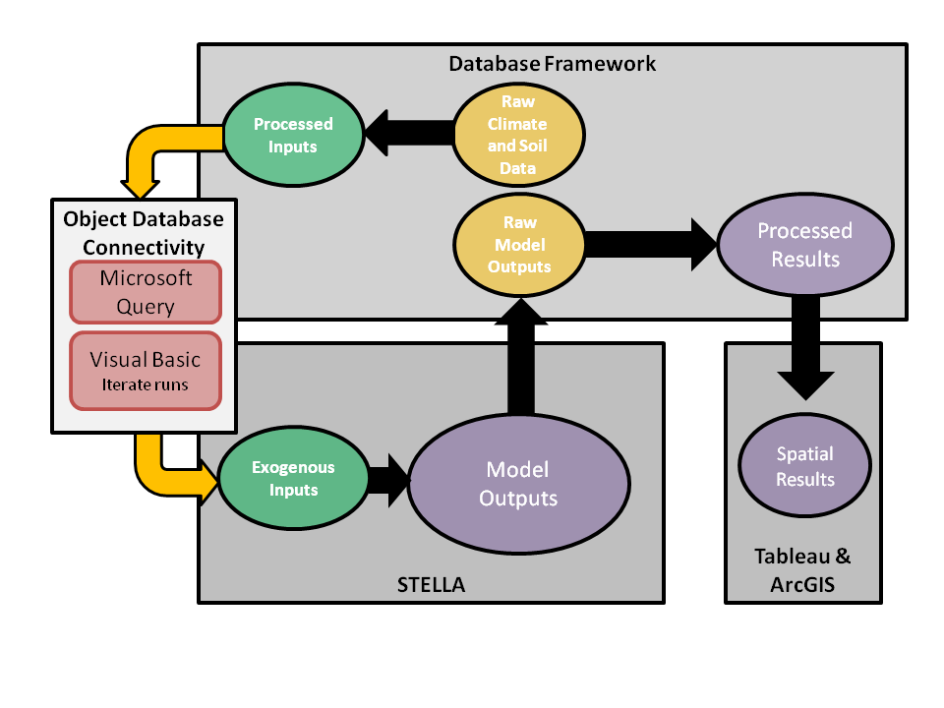**Figure 2.** Water footprinting model, data processing, and management diagram.

*3.2. Overview of Data Sources, Processing, and Management*

BioSpatial H2O is currently based on available agricultural crop data from climate data from Cligen(48) and SSURGO2.1/STATSGO2,([47](#_ENREF_47" \o "Soil Survey Staff - Natural Resources Conservation Service, (2013) #49)) but soil and climate datasets from other sources can be substituted. An overview of how data is joined and overlaid can be seen in Figure 3.

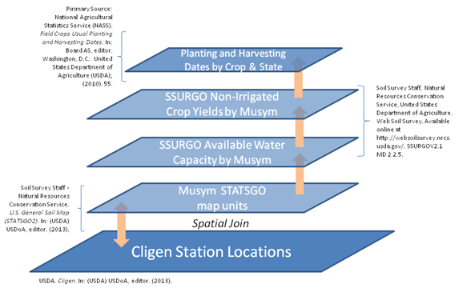

**Figure 3**. Overview of Cligen and SSURGO2.1/STATSGO2 data joining and overlay. A. NASS,([53](#_ENREF_53" \o "National Agricultural Statistics Service (NASS), (2010) #107)) B. Soil Survey Staff,([47](#_ENREF_47" \o "Soil Survey Staff - Natural Resources Conservation Service, (2013) #49)) C. Soil Survey Staff.([52](#_ENREF_52" \o "Soil Survey Staff, (2013) #119))

BioSpatial H2O uses Cligen(48) for climatic conditions. We automated the Cligen simulation to produce 30 years of daily climate data for 2,648 stations across the United States. Figure 4 shows how the number of Cligen stations provides rich spatial coverage in many states for spatial analysis such as creating surface datasets. Cligen is a stochastic climate data simulator that generates daily estimates for parameters such as precipitation (mm day-1), temperature (degrees Fahrenheit), dew point (degrees Fahrenheit), wind (km day-1), and solar radiation (MJ-day meters-2). It uses monthly parameters (e.g., mean, standard deviation, and skew) derived from historic measurements to create daily climate estimates. The database frameworks extracted, loaded, and transformed the raw data output from the SD model simulation. Using database query language, exogenous climate model inputs are generated by calculating averages of Cligen daily data by month for precipitation, temperature, dew point, and wind speed. The model inputs contain 365 daily data points for each of the 2,648 stations for each parameter.

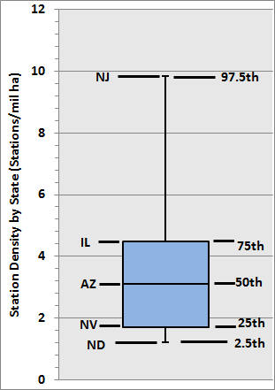

**Figure 4**. BioSpatial H2O distribution of station density by state. 2.5th, 25th, 50th, 75th, and 97.5th percentile are shown

SSURGO2.1/STATSGO2 provides data(47, 52) for soil conditions.

STATSGO2 is a generalized 1:250,000 resolution soil dataset. STATSGO2 map units (MUSYM) were determined by sampling higher resolution areas and then statistically expanding the data to characterize the entire map unit. The spatial coverage is available at state, territorial, and national extents. Biospatial H2O used the soil mapping unit at the national extents level. The STATSGO2 soil mapping units were joined to the Cligen station locations, creating a MUSYM map attribute for each climate point.

The database framework extracts soil metrics for each Cligen/STATSGO2 joined soil mapping unit from the SSURGO2.1 tabular access database. SSURGO2.1. STATSGO2 defines the spatial resolution and the associated SSURGO2.1 tabular Access database is the source of the physical soil and crop yield data which are joined and layered by the STATSGO2.1 mapping units. This layering defines the exogenous inputs. Soil input parameters used in BioSpatial H2O include available water capacity (mm day-1), and non-irrigated crop yields aggregated by each crop type into categories: perennial forage, annual forage, corn grain, feed crop, fiber crop, spring grains, oil crop, sugar crop, winter grain, and soybeans. The model uses these yields as a default, but can accept yield data from any data source that reports in SI units.

BioSpatial H2O uses crop planting and harvesting data mostly from the U.S. Department of Agriculture (USDA) National Agricultural Statistics Service(53-56) and joins the planting and harvesting dates to the Cligen locations and STATSGO2 mapping units by crop type, and used those as exogenous inputs for calculating the crop coefficients (see section 3.3 below). The database framework calculates an average planting and harvesting date across multiple crops to represent aggregate biofuel crop categories within the model.

BioSpatial H2O datasets are limited in several key respects despite the high resolution. The datasets available for operating BioSpatial H2O limit the ability to model crops in regions with intermittent growth and no database is available. Another issue is that Cligen climate data are based on a location sampling driven by available stations. This contrasts with SSURGO2.1/STATSGO2 data, which are relatively high resolution and completely cover most of the continental United States. Cligen station coverage of the United States is relatively complete (i.e., at least a dozen stations in each state), but that does not preclude bias such as from a low sample size. Harvest and planting date data is also not as complete as available Cligen stations, so the actual stations in use for each crop category will vary by feedstock. Finally, the climate and soil data management system is more complex than the SD model and would not be as easily modified by users inexperienced in database management and model automation.

*3.3. Overview of the SD Model*

The Penman-Monteith method equations(28) and the SD model they reside in are simple parsimonious and readily modifiable by users. Figure 4 illustrates the generalized influence diagram of the SD model for estimating green and blue water consumption. Green water (M3 Mg-1) is determined by the available soil water and crop evapotranspiration rates. Available soil water is constrained as determined by average precipitation and soil texture. Crop evapotranspiration is calculated based on an evapotranspiration reference surface (i.e., the ET of a natural ecosystem) and an endogenous or exogenous (user-defined) crop coefficient. The reference surface evapotranspiration is calculated using the daily time step method outlined in Chapter 4 of FAO paper number 56. (28) The crop coefficient (Kc) in our model can be either exogenous or calculated endogenously. The illustrative results presented in this paper are based on the endogenous calculation of Kc. For the endogenous crop coefficient calculation, the model uses the single crop coefficient approach as outlined in Chapter 6 of FAO paper number 56.(28) In our model, the Kc curve is constructed to reflect various wetting events, variable growing seasons (spring-summer rotations, winter rotations, and perennial crops), and variable soil textures.

Blue water consumption (M3 Mg-1) of agricultural feedstocks are estimated using a calculation framework (i.e., Penman-Monteith) that was intended to develop irrigation schedules for individual fields using crop yields and crop evapotranspiration rates. However, BioSpatial H2O specifically does not model “actual” blue water consumption. Actual blue water consumption represents what a farmer applied and what is used by an agricultural crop. Actual water consumption is likely lower than a theoretical “full yield” water consumption depending on the individual producer’s risk tolerance and resulting acceptance of yield reductions.(28) For example, farmers may deliberately not irrigate if local water resources are restricted (e.g., by physical availability, lack of irrigation infrastructure, or by public policy) or market conditions are such that irrigation is not cost-effective. Water consumption behavior and its effects have been measured differently across studies.(23)

BioSpatial H2O does not make assumptions regarding producer- and field-level management decisions. BioSpatial H2O does not use irrigation survey data such as from the USDA because the model is intended to be flexible to be used in estimating potential future scenarios in which other crops are grown, other climatic conditions are assumed, or other irrigation behaviors may occur. The Penman-Monteith framework, as applied in BioSpatial H2O, calculates the blue water footprint as the difference between the crop’s physiological requirement for water and what is supplied by soil water (i.e., green water). The blue water footprint, as calculated in this model, is affected by an assumed tolerance to crop yield loss. For purposes of illustration, we have assumed this parameter to be zero. In other words we assume that there is no tolerance to yield reduction. Blue water results from BioSpatial H2O should be viewed as the “theoretical” and/or “maximum” blue water footprint. In practices there will be some level of tolerance to yield that varies over geographic areas. The model could be modified to be water minimizing with the appropriate data.

The SD model calculates green and blue water consumption for aggregate agricultural crops where SSURGO2.1/STATSGO2 data are available. Default BioSpatial H2O outputs include blue and green water for the following aggregated crop categories: perennial forage, annual forage, corn grain, feed crop, fiber crop, spring grains, oil crop, sugar crop, winter grains and soybeans; additional aggregations of SSURGO2.1/STATSGO2 crops are also possible.

The “product-purpose” allocation approach is used in our model with regard to attributing a given water footprint to an agricultural crop/product. For example, the water footprint attributed to growing corn grain is fully attributed the corn grain. However, if one were to include the harvest of corn grain and corn stover, the water footprint could be easily be allocated among the respective harvested portions of the crop using any number of user-defined allocation methods. Equations in the STELLA model are based on FAO’s Penman-Monteith method,(28) which are modified from Allen (1998),(28) and are solved daily.



**Figure 5.** SD model overview diagram.

*3.5. Model Verification*

BioSpatial H2O results have been validated against available literature. Below we compared green and blue water footprinting results to data primarily from Chiu et al.([40](#_ENREF_40" \o "Chiu, (2012) #64)) as well as other studies. (11, 29, 41, 42, 57, 58) Data from Chiu et al.([40](#_ENREF_40" \o "Chiu, (2012) #64)) is presented based on the “product-purpose” allocation approach to allow for comparison. Ideally, BioSpatial H2O’s results would be compared to site-specific cases, as represented in the Cligen data used for calculations. However, as outlined in Section 1.3, options for high geographic resolution water consumption assessment are limited.

**4. WATER FOOTPRINTING RESULTS**

*4.1. Discussion of Illustrative Results and Comparison to Other Studies*

BioSpatial H2O blue and green water footprints for corn grain and soybeans, by Cligen station, are shown in Figures 6. As expected, green water footprints for both crops are greater in the western United States. Overall water footprint trends for corn grain and soybeans are commensurate with those in the literature (e.g., Chiu et al.(40), Gerbens-Leenes et al.(29), and Dominguez-Faus et al.(41)). For example, overall water requirements generally increase when moving into hotter and/or drier climates.

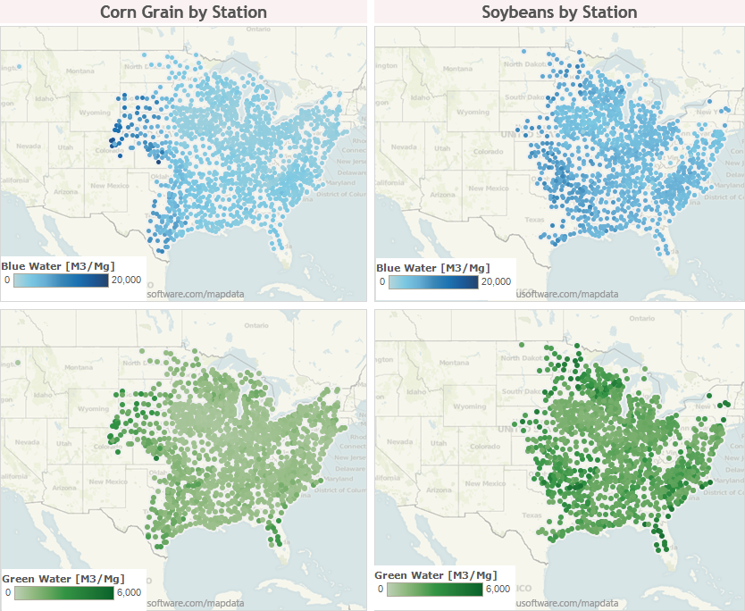

**Figure 6.** BioSpatial H2O corn grain and soybean station coverage for green and blue water consumption. Blue water is based on “full growth” water consumption if one were to maximize crop yield.

Plots of green water variance, by state, for both corn and soybeans are shown in Figure 7 compared to a similar data set from Chiu et al.([40](#_ENREF_40" \o "Chiu, (2012) #64)) Similar blue water consumption figures are included in the supporting information. Blue water consumption is included only for illustrative purposes due to BioSpatial H2O estimating maximum water consumption to achieve “full yields”.

NREL average corn grain and soybean green water consumption is generally higher than ANL by state. However, overall, the estimates for corn and soybean green water footprints mostly compare well. NREL data includes more variance in estimates especially for some states such as Nebraska, South Dakota, and Arkansas. Larger variance in the NREL dataset is likely due to localized variability that would not be captured in the state and county averages of other analyses.

State-level results from BioSpatial H2O compare well with other published analyses. (42, 58) As expected, results from BioSpatial H2O show that states such as Iowa, Minnesota, Wisconsin, and Illinois have higher green water footprints than drier states like Nebraska, Colorado, and Kansas.

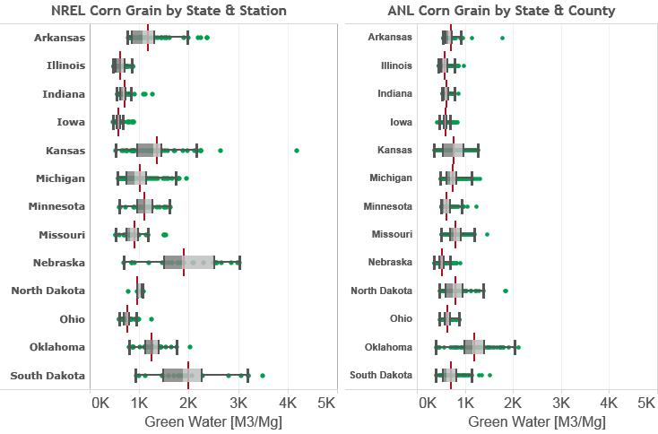

**Frame A**

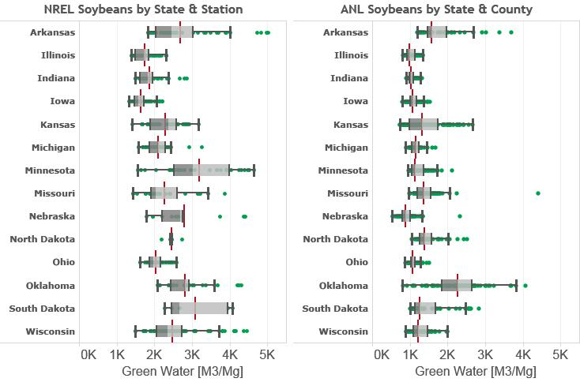

**Frame B**

**Figure 7.** Corn grain (frame A) and soybean (frame B) green water consumption by state. Green dots represent stations in the NREL data and county average in the ANL data. Box and whisker plots represent the average value along with the 2.5th, 25th, 50th, 75th, and 97.5th percentiles.

*4.2. Water Footprinting Tool Flexibility and Improvements to Scenario Analysis*

BioSpatial H2O builds on previous water consumption analyses to provide a platform for a more complete scenario based assessment. BioSpatial H2O’s scenario We have only shown results for corn grain and soybeans in this study for illustrative and validation purposes. BioSpatial H2O models green and blue water footprints from multiple agricultural crops at a several levels of geographic aggregations in the continental U.S. such as to yieldExpansion or modification of BioSpatial H2O to new conditions and applications would take time, but are also possible using SD.

BioSpatial H2O’s dynamic capabilities and adjustable climatic data allow analysis of water consumption in relation state and national bioenergy policies (e.g., US EPA([59](#_ENREF_59" \o "EPA, (2010) #3)) and EU([60](#_ENREF_60" \o "European Commission, (2009) #2))) and potential future policies. The model could be adapted for scenario analysis of alternative crop categories, locations where those crops are grown, and under alternative climatic conditions if the data is available. For example, BioSpatial H2O could be adapted to run scenarios looking at the water footprints of feedstock overtime as research and development (R&D) improves yields, drought tolerance, and other physiological factors. Future climate data (e.g., regression of Cligen data) to estimate the potential future crop water footprints could also be included. The results of such an analysis would help identify areas of risks associated with water consumption competition in particular regions among feedstocks and identify (R&D) pathways that increase or decrease the risk of water consumption competition. A potential scenario analysis of alternative future policies such as the Renewable Fuel Standard 2([59](#_ENREF_59" \o "EPA, (2010) #3)) and proposed revision could be examined in the context of potential future climatic conditions.

BioSpatial H2O is not currently built to model “actual” blue water consumption. One example scenario analysis to reconcile farmer behavior with plant physiological requirements is the opportunity to run scenarios in a top down analysis of the theoretical blue water footprint compared to self-reported irrigation from the USDA.(61) This yield loss tolerance factor could be modified by state, county, or even station level to represent irrigation constraints and farmer’s choices with regards to irrigation. A potential analysis would include comparing actual yields to potential yields for a defined area, calculating the blue water footprint based on a yield loss tolerance factor reflecting actual yields, and comparing the blue water footprint to self-reported irrigation from the USDA.(61)

BioSpatial H2O could be adapted for scenario analysis outside biofuels or the U.S. BioSpatial H2O can assess a wide array of agricultural commodities. The current version of BioSpatial H2O is designed to evaluate water consumption in agriculture crops. There is potential to adapt the database and SD framework to evaluate the water consumption of other energy technologies or water consumption in biomass conversion to fuel, heat, or power. BioSpatial H2O be used as an input into decision-making in other sectors. BioSpatial H2O also has the potential to be adapted for analysis of water consumption of less researched regions (e.g., developing countries) of the world. BioSpatial H2O’s database could be modified for other geographic contexts where climate and soil data for running the model are available.

**5. SUMMARY**

Our review of water consumption analysis literature revealed several limitations in existing water footprinting assessments that present a barrier to a more robust understanding of biofuel water consumption. Water consumption analyses often estimate aggregate water consumption from multiple sources, aggregate to national and geographic levels, cover a limited set of agricultural feedstocks, and lack flexibility to alter input assumptions.

To address these limitations we developed BioSpatial H2O based on a database framework that provides Cligen climate and STATSGO2 soil data to an SD model and catalogues the results. BioSpatial H2O’s water footprints for corn grain and soybean crops are comparable to existing water footprinting research, albeit with greater variability owing to the use of station-level rather than county- or state-level data. BioSpatial H2O’s coverage was not as extensive as reported water consumption due to the lack of spatially explicit data for many states west of the Rocky Mountains. Results are comparable to previous analyses of optimal water consumption despite being limited by the resolution of available data, and the complexity of data management could be a barrier to use.

BioSpatial H2O allows for reporting at several geographic levels disaggregated over multiple water sources over time. The tool can also evaluate many agricultural feedstocks used for bioenergy, food, feed, and food in current and potential future use. Finally, the model and database structure could be a adapted to evaluate other energy technologies with relatively high water consumption impacts such as biopower and solar.(62) Potential future analyses with the BioSpatial H2O include estimating water footprints for alternative climate change scenarios, looking at water footprints of understudied countries where climate data are available, and examining water tradeoffs of alternative cellulosic feedstocks for biofuels in multiple U.S. locations.

ACKNOWLEDGEMENTS

This work was supported by the Office of Electricity Delivery and Energy Reliability. To our knowledge, the authors do not have any other potential conflicts of interest. Daniel Inman contributed to project scoping, major contributions to model development, and major contributions to the writing of the paper. Ethan Warner provided major contributions to the writing of the paper. Dana Stright provided major contributions to the STATSGO2 and CLIGEN database framework and minor writing contributions. Jordan Macknick provided major contributions to project scoping and minor contributions to writing. Corey Peck provided minor contributions to model and database framework development. Thanks Emily Newes, Margaret Mann, and Nate Blair.

**7. References**

1. Pfister S, Koehler A, Hellweg S. Assessing the Environmental Impacts of Freshwater Consumption in LCA. *Environmental Science & Technology*. (2009);**43**(11):4098-104.

2. Matti K, Philip JW, Hans de M, Olli V. Is physical water scarcity a new phenomenon? Global assessment of water shortage over the last two millennia. *Environ Res Lett*. (2010);**5**(3):034006.

3. UNESCO. *The United Nations World Water Development Report 3: Water in a Changing World*. Paris and London: UNESCO and Earthscan (2009).

4. National Drought Mitigation Center. *National Drought Summary May 28, 2013*. Lincoln: University of Nebraska-Lincoln, the United States Department of Agriculture, and the National Oceanic and Atmospheric Administration, (2013) May 28. Report No.

5. Kenneth S, Gary Y, James N, Brent B. Characterizing changes in drought risk for the United States from climate change. *Environ Res Lett*. (2010);**5**(4):044012.

6. Hoekstra AY, Chapagain AK. Water footprints of nations: Water use by people as a function of their consumption pattern. *Water Resources Management*. (2007);**21**(1):35-48.

7. Falkenmark M. Comparative hydrology—a new concept. In: Falkenmark M, Chapman T, editors. *Comparative Hydrology An Ecological Approach to Land and Water Resources*. Unesco, Paris, France(1989). p. 10-42.

8. Postel SL. Entering an Era of Water Scarcity: The Challenges Ahead. *Ecological Applications*. (2000);**10**(4):941-8.

9. Postel SL, Daily GC, Ehrlich PR. Human Appropriation of Renewable Fresh Water. *Science*. (1996);**271**(5250):785-8.

10. Gleick PH. The human right to water. *Water Policy*. (1998);**1**(5):487-503.

11. Fingerman KR, Torn MH, O’Hare MS, Kammen DM. Accounting for the water impacts of ethanol production. *Environ Res Lett*. (2010);**5**(1):014020.

12. Wu M, Mintz M, Wang M, Arora S. Water Consumption in the Production of Ethanol and Petroleum Gasoline. *Environ Manage*. (2009);**44**(5):981-97.

13. Wu M, Mintz M, Wang M, Arora S. Consumptive Water Use in Bioethanol and Petroleum Gasoline Pathways. Transportation Research Board 89th Annual Meeting; Washington, D.C.(2010).

14. Chakravorty U, Hubert M-H, Nøstbakken L. Fuel Versus Food. *Annual Review of Resource Economics*. (2009);**1**(1):645-63.

15. Hoekstra AY, Gerbens-Leenes PW, Van der Meer TH. Climate change and water : international perspectives on mitigation and adaptation. In: Smith J, Howe C, Henderson J, editors. *The water footprint of bio-energy*. London, UK: American Water Works Association, IWA Publishing; (2010). p. 81-95.

16. Berndes G. Bioenergy and water--the implications of large-scale bioenergy production for water use and supply. *Global Environmental Change*. (2002);**12**(4):253-71.

17. Berndes G. Future Biomass Energy Supply: The Consumptive Water Use Perspective. *Int J Water Resources Development*. (2008);**24**(2):235 - 45.

18. Chum H, Faaij A, Moreira J, Berndes G, Dhamija P, Dong H, et al. Bioenergy. In: Edenhofer O, Pichs-Madruga R, Sokona Y, Seyboth K, Matschoss P, Kadner S, et al., editors. *IPCC Special Report on Renewable Energy Sources and Climate Change Mitigation*. Cambridge, United Kingdom and New York, NY, USA: Cambridge University Press; (2011). p. 124.

19. Dornburg V, Faaij A, Verweij P, Langeveld H, van de Ven G, Wester F, et al. *Assessment of Global Biomass Potentials and their Links to Food, Water, Biodiversity, Energy Demand and Economy*. Bilthoven, Netherlands: The Netherlands Environmental Assessment Agency, (2008) Contract No.: WAB 500102 012.

20. Rost S, Gerten D, Hoff H, Lucht W, Falkenmark M, Rockstrom J. Global potential to increase crop production through water management in rainfed agriculture. *Environ Res Lett*. (2009);**4**(4):044002.

21. Berndes G. *Water demand for global bioenergy production: trends, risks and opportunities. Report commissioned by the German Advisory Council on Global Change (Wissenschaftlicher Beirat der Bundesregierung Globale Umweltveränderungen - WBGU)*. Göteborg, Berlin: WBGU; (2008). 46 p.

22. Hsu DD, Inman D, Heath GA, Wolfrum EJ, Mann MK, Aden A. Life Cycle Environmental Impacts of Selected U.S. Ethanol Production and Use Pathways in 2022. *Environmental Science & Technology*. (2010);**44**:5289–97.

23. Yeh S, Berndes G, Mishra GS, Wani SP, Elia Neto A, Suh S, et al. Evaluation of water use for bioenergy at different scales. *Biofuels Bioprod and Bioref*. (2011);**5**(4):361-74.

24. Hoff H, Falkenmark M, Gerten D, Gordon L, Karlberg L, Rockström J. Greening the global water system. *J Hydrol*. (2010);**384**(3–4):177-86.

25. Rockström J, Falkenmark M, Karlberg L, Hoff H, Rost S, Gerten D. Future water availability for global food production: The potential of green water for increasing resilience to global change. *Water Resources Research*. (2009);**45**(7):W00A12.

26. USDA. *Water Erosion Prediction Project (WEPP)*. West Lafayette, IN, (1995).

27. Parton WJ, Hartman M, Ojima D, Schimel D. DAYCENT and its land surface submodel: description and testing. *Global and Planetary Change*. (1998);**19**(1–4):35-48.

28. Allen RG, Pereira LS, Raes D, Smith M. *FAO Irrigation and Drainage Paper*. Rome, Italy: FAO; (1998). 333 p.

29. Gerbens-Leenes W, Hoekstra AY, van der Meer TH. The water footprint of bioenergy. *Proceedings of the National Academy of Sciences*. (2009);**106**(25):10219-23.

30. Hoekstra AY, Chapagain AK, Aldaya MM, Mekonnen MM. *Water Footprint Manual State of the Art 2009*. Enschede, The Netherlands: Water Footprint Network, (2009).

31. FAO. *CropWAT Model version 8*. Food and Agricultural Organization (FAO),, (2010).

32. Food and Agricultural Organization (FAO). CLIMWAT Model version 2. Food and Agricultural Organization (FAO),, (2010).

33. Orang MN, Matyac JS, Snyder RL. *Consumptive Use Program + (CUP+) Model*. California: California Department of Water Resources, (2009).

34. Wu M, Chiu Y, Demissie Y. Quantifying the regional water footprint of biofuel production by incorporating hydrologic modeling. *Water Resources Research*. (2012);**48**(10):W10518.

35. Chiu Y-W, Wu M. Considering water availability and wastewater resources in the development of algal bio-oil. *Biofuels, Bioproducts and Biorefining*. (2013);**7**(4):406-15.

36. Yi-Wen C, May W. The water footprint of biofuel produced from forest wood residue via a mixed alcohol gasification process. *Environmental Research Letters*. (2013);**8**(3):035015.

37. Gheewala SH, Berndes G, Jewitt G. The bioenergy and water nexus. *Biofuels Bioprod and Bioref*. (2011);**5**(4):353-60.

38. Gerbens-Leenes PW, Hoekstra AY, van der Meer T. The water footprint of energy from biomass: A quantitative assessment and consequences of an increasing share of bio-energy in energy supply. *Ecological Economics*. (2009);**68**(4):1052-60.

39. NAS. *Water Implications of Biofuels Production in the United States*. Washington, D.C.: The National Academies Press; (2008). 88 p.

40. Chiu Y-W, Wu M. Assessing County-Level Water Footprints of Different Cellulosic-Biofuel Feedstock Pathways. *Environmental Science & Technology*. (2012);**46**(16):9155-62.

41. Dominguez-Faus R, Powers SE, Burken JG, Alvarez PJ. The Water Footprint of Biofuels: A Drink or Drive Issue? *Environmental Science & Technology*. (2009);**43**(9):3005-10.

42. Mishra GS, Yeh S. Life Cycle Water Consumption and Withdrawal Requirements of Ethanol from Corn Grain and Residues. *Environmental Science & Technology*. (2011);**45**(10):4563-9.

43. King CW, Webber ME. Water Intensity of Transportation. *Environmental Science & Technology*. (2008);**42**(21):7866-72.

44. Chiu Y-W, Walseth B, Suh S. Water Embodied in Bioethanol in the United States. *Environmental Science & Technology*. (2009);**43**(8):2688-92.

45. Molden D. *Water for Food, Water for Life: a Comprehensive Assessment of Water Management in Agriculture*. London: Earthscan/James & James; (2007).

46. Ford A. *Modeling the environment: an introduction to system dynamics models of environmental systems*. Ann Arbor, Michigan: Island Press; (1999).

47. Soil Survey Staff - Natural Resources Conservation Service. *U.S. General Soil Map (STATSGO2)*. In: (USDA) USDoA, editor. (2013).

48. USDA. *Cligen*. In: (USDA) USDoA, editor. (2013).

49. ISEE Systems. STELLA v.9.1.4. Lebanon, NH, USA 2013.

50. Forrester JW. System dynamics: the next fifty years. *System Dynamics Review*. (2007);**23**:359-70.

51. Ghaffarzadegan N, Lyneis J, Richardson GP. How small system dynamics models can help the public policy process. *System Dynamics Review*. (2011);**27**:22-44.

52. Soil Survey Staff. Web Soil Survey SSURGOV2.1 MD 2.2.5. In: Natural Resources Conservation Service USDoA, editor. (2013).

53. National Agricultural Statistics Service (NASS). *Field Crops Usual Planting and Harvesting Dates*. In: Board AS, editor. Washington, D.C.: United States Department of Agriculture (USDA); (2010).

54. Buntin GD, Cunfer BM, editors. *Southern Small Grain: Resource Management Handbook*. Athens, GA: University of Georgia College of Agricultural and Environmental Sciences Cooperative Extension; (2013).

55. Bates G, Harper C, Allen F. Forage & Field Crop Seeding Guide for Tennessee. Knoxville, TN: Univeristy of Tennessee Institute of Agriculture, (2011).

56. Collins HP, Boydston R, Alva A, Hang AN, Fransen S, Wanderschnieder P. BioFuel Variety Trials. In: (USDA) USDoA, editor. (2005).

57. King CW, Webber ME, Duncan IJ. The water needs for LDV transportation in the United States. *Energy Policy*. (2010);**38**(2):1157-67.

58. Mubako S, Lant C. Water resource requirements of corn-based ethanol. *Water Resources Research*. (2008);**44**(7):W00A2.

59. EPA. *Renewable Fuel Standard Program (RFS2) Regulatory Impact Analysis*. Washington D.C., USA: US Environmental Protection Agency, (2010) Contract No.: EPA-420-R-10-006.

60. European Commission. *Directive 2009/28/EC of the European Parliament and of the Council of 23 April 2009 on the promotion of the use of energy from renewable sources*. Brussels, Belgium: European Commission, (2009).

61. NASS. *Irrigation Survey*. In: Board AS, editor. Washington, D.C.: USDA; (2013).

62. Macknick J, Newmark R, Heath G, Hallett K. A Review of Operational Water Consumption and Withdrawal Factors for Electricity Generating Technologies. Golden, CO: National Renewable Energy Laboratory, 2011 Contract No.: NREL/TP-6A20-50900.

**Supporting Information**

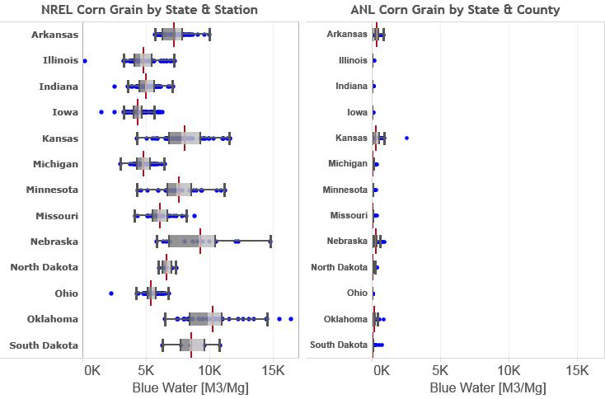

**Frame A**

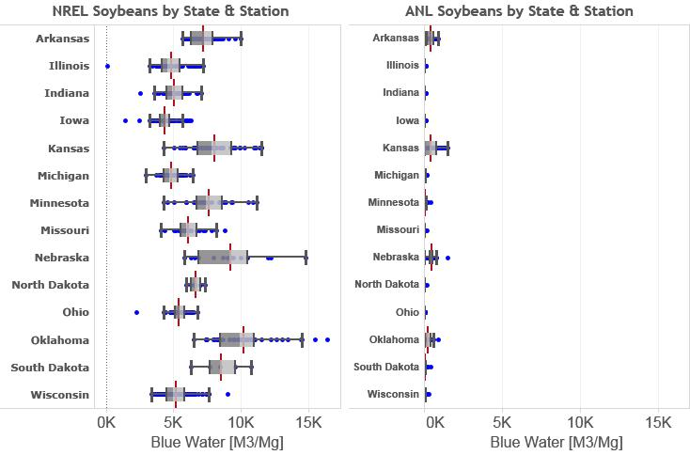

**Frame B**

**Figure 7.** Corn grain (frame A) and soybean (frame B) green water use by state. Green dots represent stations in the NREL data and county average in the ANL data. Box and whisker plots represent the average value along with the 2.5th, 25th, 50th, 75th, and 97.5th percentiles. NREL blue water use data represents maximum blue water use to get “full yields”. ANL data is based on USDA survey data.(61)

1. Correspondence to: Ethan Warner, National Renewable Energy Laboratory (NREL), 15013 Denver West Parkway, Golden, CO 80401. Phone: 303-384-7471, Fax: 303-275-4675. Email: ethan.warner@nrel.gov
2. https://github.com/NREL/waterfootprint